Create an online survey form using HTML5 and CSS

In this hands-on project, we will create an online survey form for ICT students. The form will contain a number of HTML form elements and attributes for participants to fill out.
- The final form will look like the below screen.
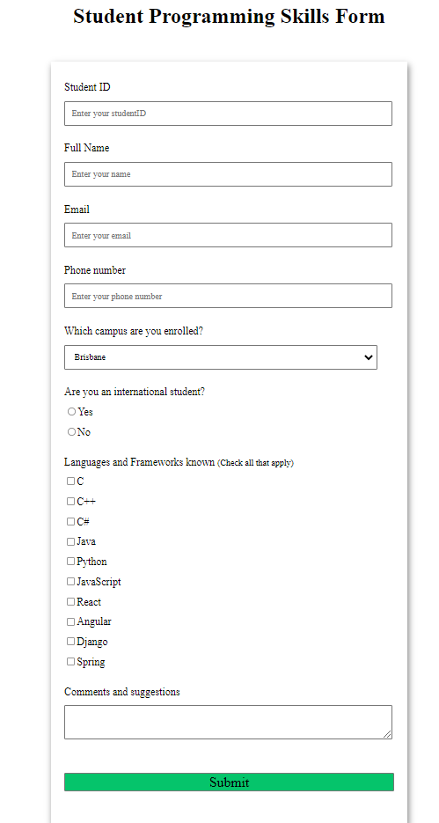

- From the Project shell folder provided, you can find a custom.css file. This css file is used for hands-on projects. Please feel free to use your own css file(s) if you like. Since the css topic is taught in the pre-requisite unit， we don’t go into details about css in this unit. Instead, we will learn a powerful css framework BootStrap5 to enhance our web development experience.
- Now open the survey.html file template. You should be able to see the stylesheet is linked to this file (line 9).

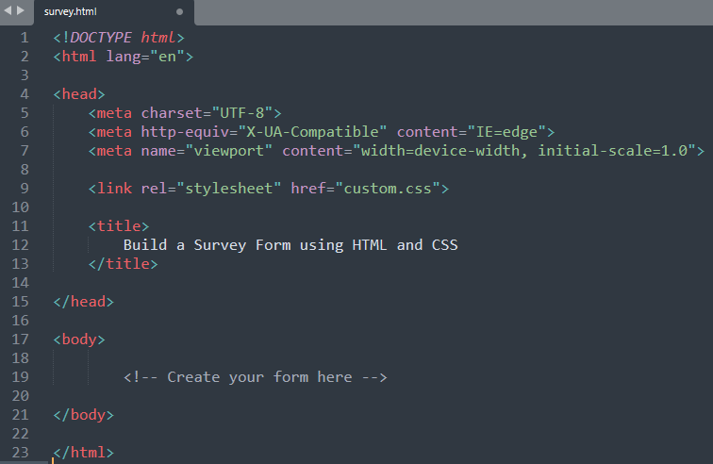
- Firstly, we need to add a heading for this form. The heading level (i.e., <h1> to <h6>) doesn’t matter.

<h1> <center>Student Programming Skills Form </center> </h1>

- We need to start with a <form> tag. The whole form elements will be contained in this <form>.
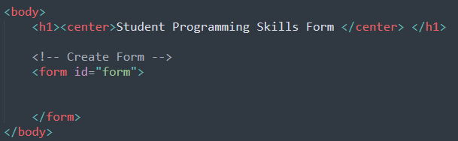

- Take a look at the form on the first page. The top 2 input fields – StudentID and Full name are with a “text” input type. Let’s create these 2 input fields. Note, that there is a “label” associated with each input field. Key points:
- Use HTML <div> tag for each input field. <div> defines a division, which make the code easy to read.
- The HTML <label> for Attribute is used to specify the type of form element a label is bound to. As in the figure below, line 23 is bound to line 29, and line 34 is bound to line 40.
- The placeholder attribute specifies a short hint that describes the expected value of an input field (e.g., a sample value or a short description of the expected format).
  - The short hint is displayed in the input field before the user enters a value.
  - Note: The placeholder attribute works with the following input types: text, search, url, tel, email, and password.

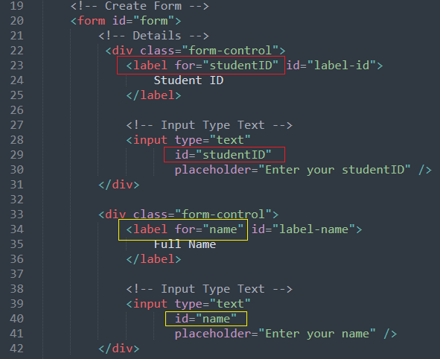

Note: <input type="text">, “text” is the default value for input type.
Tip: Always add the <label> tag for best accessibility practices!

- Save your file and refresh it in your web browser. It looks good!
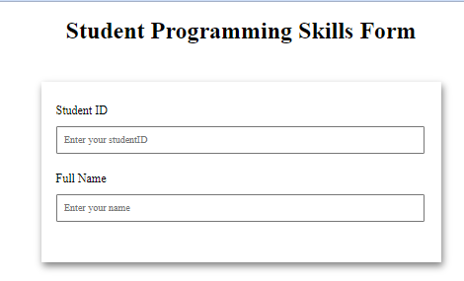

- Next, we have an email input field. HTML5 has a type attribute for the email address. The input value is automatically validated to ensure it is a properly formatted e-mail address.

<input type="email" id="email" name="email">

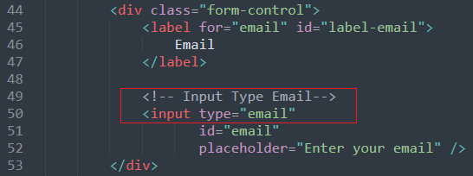

- Add another field for phone input. HTML5 has a type “tel” for the telephone number input field.
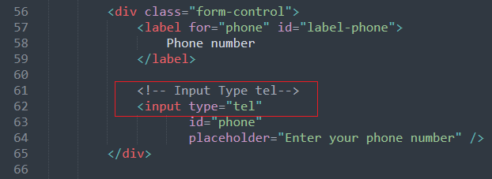
- Save and refresh the page. Now you should have 4 input fields.

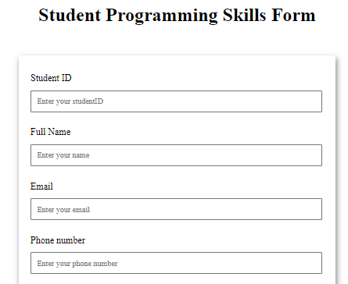

- The next element is a drop-down option for campus selection. It is defined by HTML’s <select> and <option> combination. The code is:

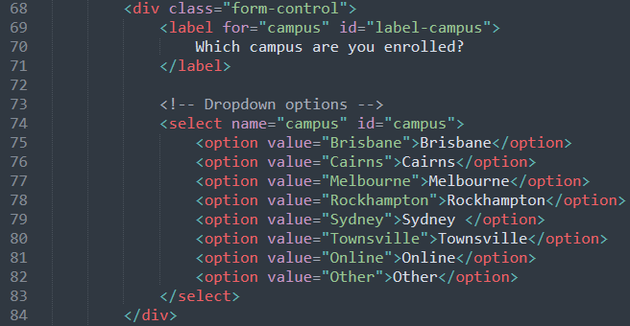

To save your time, you may copy the below code into your program:

<!-- Dropdown options -->
<select name="campus" id="campus">
<option value="Brisbane">Brisbane</option>
<option value="Cairns">Cairns</option>
<option value="Melbourne">Melbourne</option>
<option value="Rockhampton">Rockhampton</option>
<option value="Sydney">Sydney </option>
<option value="Townsville">Townsville</option>
<option value="Online">Online</option>
<option value="Other">Other</option>
</select>

Notes: The name attribute is needed to reference the form data after the form is submitted (if you omit the name attribute, no data from the drop-down list will be submitted).

- Save and refresh. The Drop-down list should be added onto the form.

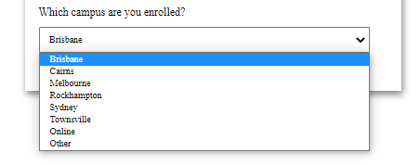
- The next element is a radio button group. We need to use <input type="radio"> attributes.

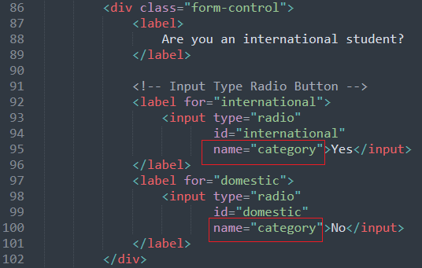

Notes:
- Radio buttons are normally presented in radio groups (a collection of radio buttons describing a set of related options). Only one radio button in a group can be selected at the same time.
- The radio group must have shared the same name (the value of the name attribute) to be treated as a group. Once the radio group is created, selecting any radio button in that group automatically deselects any other selected radio button in the same group. You can have as many radio groups on a page as you want, as long as each group has its own name.

- Save the file and refresh the browser.

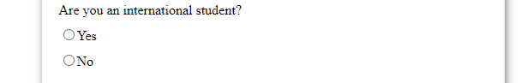

- Next, we have a long checkbox list for programming language options. The <input type="checkbox"> should be used.
- Checkboxes are used to let a user select one or more options of a limited number of choices.
- A group of checkboxes should have the same “name” (e.g., “inp” in the below checkboxes) attribute with different “values”. This will help to read the data checked.

Copy the following code onto your survey.html, just behind the above radio button group. Tidy up your code if needed.
<div class="form-control">
<label>Languages and Frameworks known
<small>(Check all that apply)</small>
</label>
<!-- Input Type Checkbox -->
<label for="inp-1">
<input type="checkbox"
name="inp" value="C">C</input>
</label>
<label for="inp-2">
<input type="checkbox"
name="inp" value="C++">C++</input></label>
<label for="inp-3">
<input type="checkbox"
name="inp" value="C#">C#</input> </label>
<label for="inp-4">
<input type="checkbox"
name="inp" value="Java">Java</input></label>
<label for="inp-5">
<input type="checkbox"
name="inp" value="Python">Python</input></label>
<label for="inp-6">
<input type="checkbox"
name="inp" value="JavaScript">JavaScript</input></label>
<label for="inp-7">
<input type="checkbox"
name="inp" value="React">React</input></label>
<label for="inp-7">
<input type="checkbox"
name="inp" value="Angular">Angular</input></label>
<label for="inp-7">
<input type="checkbox"
name="inp" value="Django">Django</input></label>
<label for="inp-7">
<input type="checkbox"
name="inp" value="Spring">Spring</input></label>
</div>

- Save and refresh your browser. You should be able to see the checkboxes.

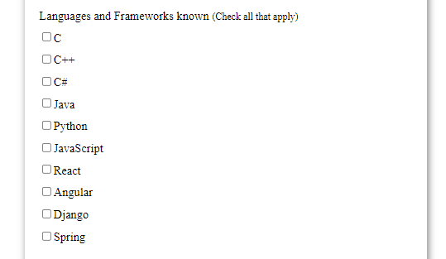

- Lastly, let’s add a ‘textarea’ for comments and a ‘submit’ button for the form submission.
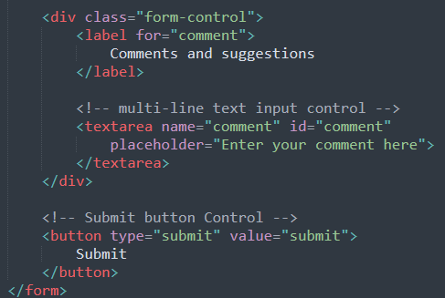
- Save and refresh the browser. You should be able to see the comments area and the Submit button.
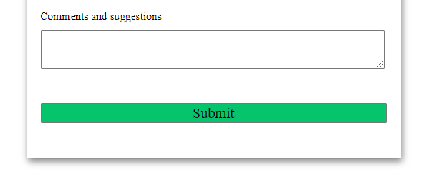

- That completes the Hands-on Project 1.

